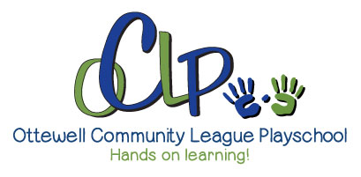

Photo Release
During the busy, busy days here at Ottewell Playschool, there are many “Kodak” moments we like to capture on film for a variety of uses. Each year the Ottewell community league likes to display photos and perhaps be included in year end scrapbooks. We also use an app called “KLASSLY” where the instructors will post photos to inform parents of events and activities happening in the classroom on a regular basis. In addition to those uses, we have occasional need for images to use for promotional purposes such as our website. Images used will not contain identifying information, i.e., child’s name. If you are comfortable with your child being included in playschool pictures, please sign your consent. If not, simply indicate your refusal and return this form.

- I hereby give permission for digital and photo images of my child, captured at Ottewell Community League Playschool class and events, to be used solely for the purposes of Ottewell Community League Playschool promotional material and publications, and waive any rights compensation or ownership there to.

- I refuse consent.

Name of Child Participant (Please Print):_______________________________
Age of Child: __________________
Name of Parent/Guardian (Please Print):_______________________________
Parent/Guardian’s Signature: ________________________________________
Date: ______________________

